
Ph 1/2 Horizen-1 trial update to include 1L AML (fit and unfit) and potentially registrational R/R cohorts
Company: Sumitomo Pharma  Drug: Enzomenib (Menin inhibitor) | Date: Mar 25, 2026  Source: clinicaltrials.gov
What happened:
- In line with intel from ASH 2025 and company guidance, Sumitomo Pharma has updated the Ph 1/2 Horizen-1 (R/R KMT2Ar or NPM1m or FLT3m or MLLr AML, 1L unfit KMT2A or NPM1m, 1L fit KMT2Ar AML, enzomenib ± Ven ± Aza, enzomenib ± gilteritinib, N=606) to a multi-cohort study across R/R and 1L, with R/R cohorts potentially registrational

Key Approval Timelines:
 | US | EU
1L unfit AML (Planned registrational; Enzomenib + Ven + Aza) | 4Q 2029  (sNDA + 6 mo, assuming enzomenib first approval in R/R AML; no changes to timelines) | NA  (The current plans in the EU remain unclear and largely hinge on partnerships. As a result, it is premature to include EU timelines at this stage; no changes to timelines)
R/R AML (Ph 1/2 Horizen-1; enzomenib ± Ven ± Aza, enzomenib ± gilteritinib) | 1Q 2028  (NDA + 8 mo; no changes to timelines) | NA  (Of note, the current plans in the EU remain unclear and largely hinge on partnerships. Additionally, the EMA may require a randomized trial; no changes to timelines)

Impact (CI PoV): High
- This update signals that Sumitomo is strategically expanding beyond relapsed/refractory into 1L fit and unfit AML
Why it matters: (CI comments in blue)
- Pivot to Registrational Intent in R/R AML
  - The trial has evolved from dose-escalation/expansion AML study to biomarker-enriched expansion (NPM1m/KMT2Ar), with Ph 2 cohorts designed to support a potential accelerated approval in R/R AML (similar to in-class competition)
  - Of note, partnership with Foundation Medicine to develop FoundationOne Heme as a companion diagnostic supports biomarker-led regulatory strategy
  - CI assumes US approval in 1Q 2028, Sumitomo highlighted launch in R/R AML expected in FY 2027 (April 2027-March 2028)
    - Assuming regulatory submission in 3Q 2027 (PCD June 2027), approval is expected by 1Q 2028
- Encouraging Early Signal Supports 1L Combination Expansion
  - Trial update to include combination cohorts alongside monotherapy reflects a parallel development strategy, accelerating potential expansion into frontline settings rather than a sequential path
  - This update is in line with CI intel gathered as ASH 2025 where it was suggested that enzomenib triplet is now opening its 1L cohort, with the clinicaltrials.gov update now reflecting this
    - “The frontline arm of the study just started; we didn’t even start enrollment. […] Yes, it is the same study but with the addition of this new cohort in frontline. […] It should open in like January, we just finalized the amendment. […] It is correct, we don’t have other data in 1L setting, this is going to be the first. I am not biased because we enrolled patients for all the menins at MD Anderson, but I actually think enzo is the best, no DS or QTcP. […] Given the good safety profile, the short PK, the limited to no interaction with azole, the efficacy, I would be surprised if it does not show the best activity in frontline as well.” – KOL, US

  - Approval in 1L unfit AML expected in…
    - Based on CI intel, the first data from 1L cohorts is expected at ASH 2026
      - “I hope first data [referring to the triplet in 1L unfit AML] will be at ASH next year [2026]. We hope to have at least kind of a pilot and then the phase three's and all are already being discussed, so we’ll see” – KOL, US

    - Assuming the initiation of the planned Ph 3 study aggressively in 1Q 2027, it could lead to an aggressive submission in 2Q 2029
Tell me more:
Key changes in the trial design:
 | Parameters |  | Updates
PCD |  | Jun 2027 (previously Apr 2027)
SCD |  | Dec 2027 (previously Oct 2027)
N |  | 606 (previously 362)
Number of Arms |  | 14 (previously 8)
 | Experimental treatment arms |  | Arm A (Enzomenib) (Ph 1): R/R acute leukemia without CYP3A4 inhibitor azoles (updated, previously - Patients not taking antifungals within 7 days of study entry)
 |  |  | Arm B (Enzomenib + azoles) (Ph 1): R/R acute leukemia with CYP3A4 inhibitor azoles (updated, previously - Patients receiving antifungals that are moderate to strong cytochrome CYP3A4/5 inhibitors)
 |  |  | Arm E (Enzomenib + Ven + Aza) (Ph 1): R/R AML with NPM1m or KMT2Ar (updated, previously - Patients with AML)
 |  |  | Arm F (Enzomenib +Gilteritinib) (Ph 1): R/R AML with FLT3m + NPM1m or KMT2Ar (updated, previously - Patients with AML)
 |  | Arm G (Enzomenib) (Ph 2): R/R AML with MLLr
 |  | Arm H (Enzomenib) (Ph 2): R/R AML with NPM1m
 |  | Arm I (Enzomenib) (Ph 2): R/R ALL with MLLr
 |  |  | Arm J (Enzomenib + azoles) (Ph 2): R/R acute leukemia with MLLr (new arm)
 |  |  | Arm K (Enzomenib + azoles) (Ph 2): R/R AML with NPM1m (new arm)
 |  |  | Arm L (Enzomenib + Ven + Aza) (Ph 1): Newly diagnosed AML KMT2Ar FIT or UNFIT (new arm)
 |  |  | Arm M (Enzomenib + azoles + Ven + Aza) (Ph 1): Newly diagnosed AML NPM1m UNFIT only (new arm)
 |  |  | Arm N (Enzomenib + 7+3) (Ph 1): Newly diagnosed AML with KMT2Ar or NPM1m (new arm)
 | Primary Endpoints |  | - AEs  - Determination of RP2D  - CR, CRh

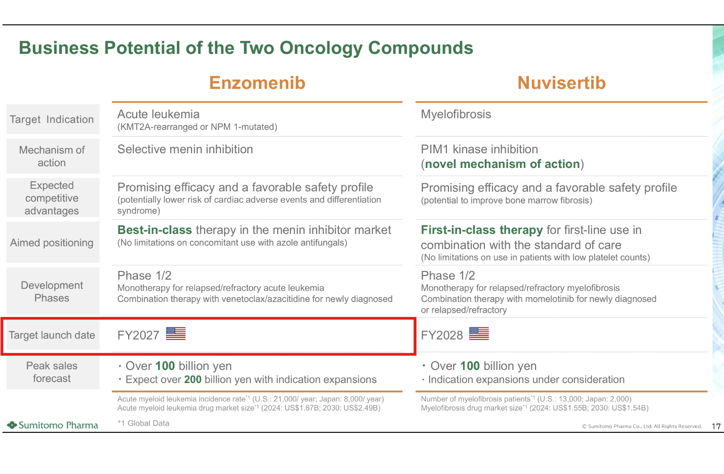

For questions, please reach out to:
International / Affiliates: Harjit Bajwa
US: Richa Sharma

Invite your colleagues to CI Edge | Manage Email Preferences | Unsubscribe

This document/email contains competitive intelligence collected via an approved competitive intelligence supplier working on behalf of AbbVie. We collect competitive intelligence consistent with industry standards and AbbVie policy. Not for field distribution. Please reach out to APEX/IMABI, Legal, or OEC teams with any questions.

